Britain meets Norway – Douze points
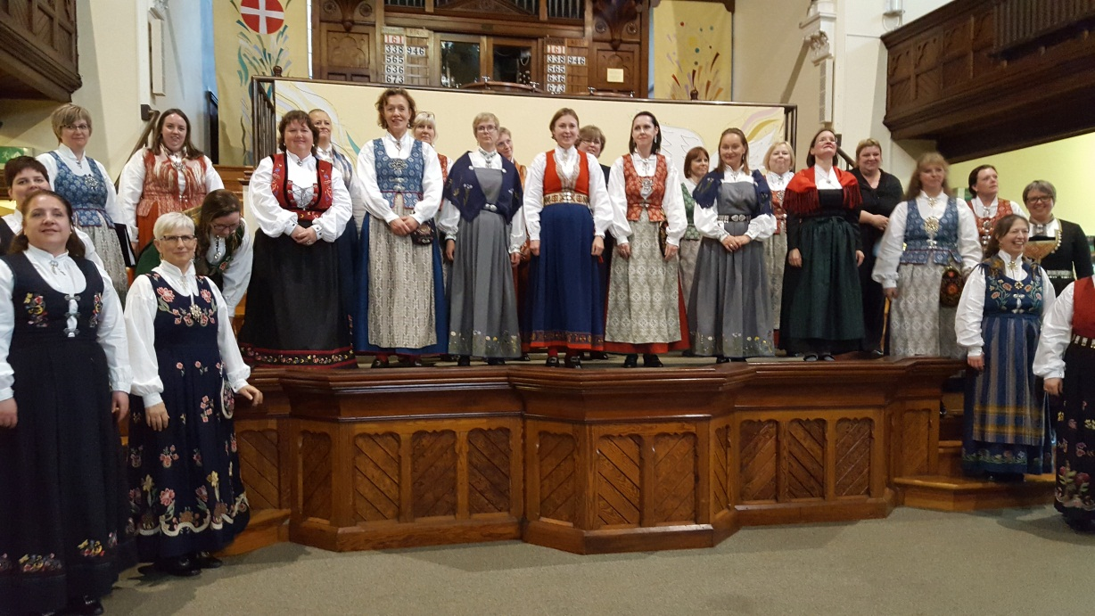

I have been floating on a cloud of ‘Inspiration’ since Friday night. What a weekend and what a pleasure to sing with such a talented choir made up of such a lovely group of people. You will have heard from other sources about the various social events of the weekend – the singing at Malt Cross, the meals and the inevitable opportunities for post-prandial songs, so I will focus on the aspects of the visit which brought WBSS and Hedda so tunefully and joyously together.
The first event of the weekend for me was the concert at Beeston Methodist Church – featuring Hedda and Bling. I was late, having gone to the wrong church, which was eerily silent, so I had to do a quick satnav dash around the corner – but I did get there for ‘Inspiration’. It was a very good turnout with quite a few WBSS friends in the audience. My daughter Jo came with me, as she is learning Norwegian and has a BFF in Oslo, so I think she hoped to recognise the odd word. I could see her looking down from the balcony with a puzzled expression during the first few songs and then when Bling Singers took to the stage, she exhaled and said ‘Ah, that explains it. I thought they were a hen party!’ She was obviously struggling to understand why a hen party would attend a concert in a Methodist Church rather than hit the bars in Nottingham!
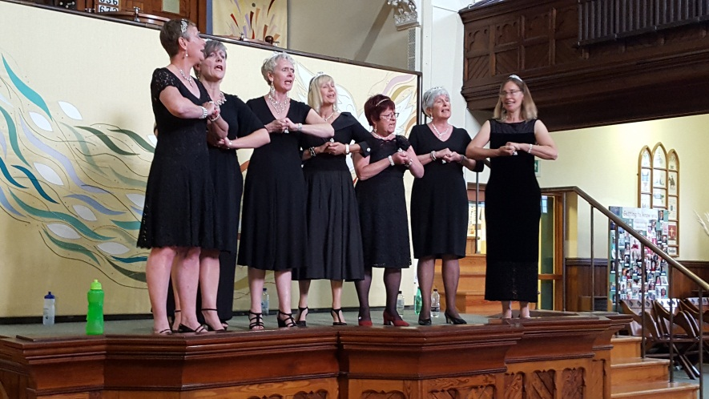
Anyway, back to the singing. The first half was a wonderful mixture of Norwegian folk songs and English popular songs. The singers wore traditional costume which was so beautiful to see; can you imagine, though, how hot it must have been on warm summer evening? I believe the costumes are referred to as ‘bunad’ and obviously vary according to region or even to village. They are also expensive and much-loved, so I am sure we are all very grateful to the Hedda ladies for bringing them in their luggage to England and letting us enjoy them. My only question is – where were Bjorn’s knee breeches?
(apologies – I’m sure these are not Norwegian!)
I love watching Bjorn conduct the choir – his whole body, from head to toe, exudes rhythm and enthusiasm – even from behind! And his explanation of the Norwegian songs is a riot. I saw some of the Hedda ladies raise eyebrows from time to time - as he tried to explain to us the essence of a song. My particular favourite was ‘Astrid mi Astrid’ which Bjorn described as a dialogue between a young lady and her boyfriend who was ‘a bit stupid’, but she chooses the right man in the end. So, you know me – on to the t’internet to discover the truth of this song. I will give you the link to the translation I found, but here are a couple of examples of an even worse translation than Bjorn’s
Astri! my Astri! your heart mine alone was,
in those old days of our joy and delight!
You always wept when our eventide flown was,
tho’ we did then meet each Saturday night.
And later:

Henceforth, I’ll court Svanaug, good-hearted
she always seems, and so loving and kind;
it was her fine Long Harp playing first started
me to go see her, she now shall be mine
Astrid responds:

savage and cross as a troll you are growing,
falser than foam on the waters to me.

Then the silly girl declares undying love for him!

A tale which clearly shows the fickle nature of long harp attraction. If you want to see the full translation: http://lyricstranslate.com/en/astrid-mi-astrid-astrid-my-astrid.html

What a contrast then with their last song of the first half ‘Even when he is silent’ – a poem written by a Jewish prisoner on the wall of a concentration camp. So beautiful and so poignant.

The Bling Singers entertained us before and after tea and cake and I must say they looked ‘naughtier’ than ever, particularly in ‘Diamonds’, where Joan’s contribution nearly brought the house down! Sometimes, the complicated arrangements left me happily breathless but it is a tribute to Elizabeth and the gang that they took this in their stride and made us all smile whilst appreciating the harmony and the performance. It’s great that we can keep Bling, even when we have to say goodbye to Hedda!

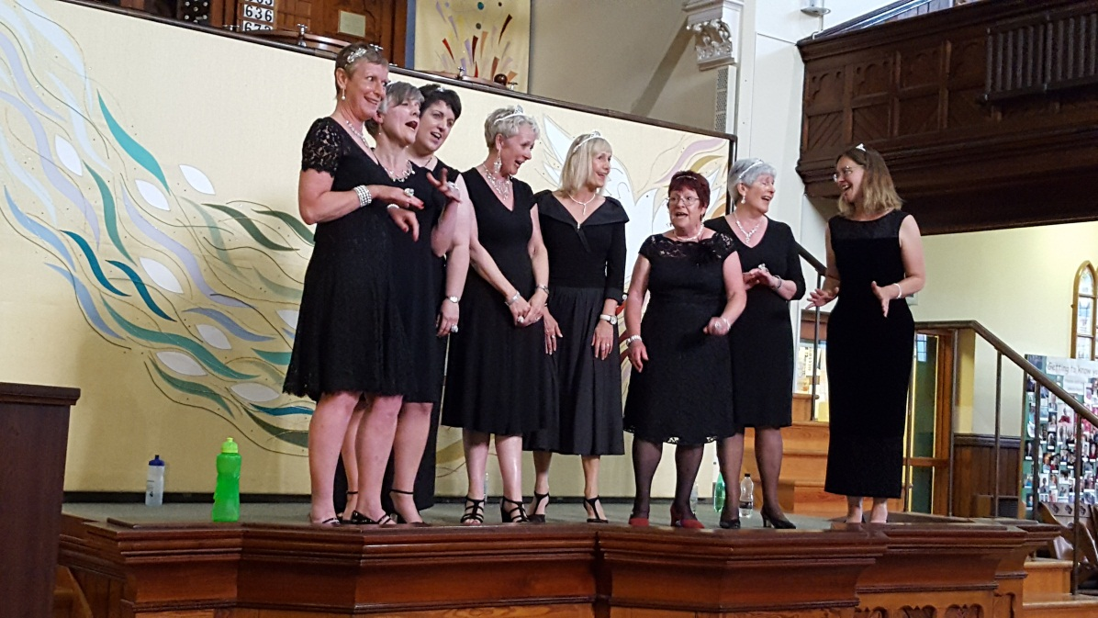

And so to Saturday and a packed afternoon of singing and mingling with a load of food thrown in (well not literally thrown – beautifully displayed on plates). Having experienced the bounty of Castle Acre, I could tell that Fiona had been rather concerned about the quantity of food required. Well, I feel we rose to the occasion and provided a splendid buffet. I forgot to take a photo at the start of lunch, so here is one, after the crowds had descended! You can still see the quality.

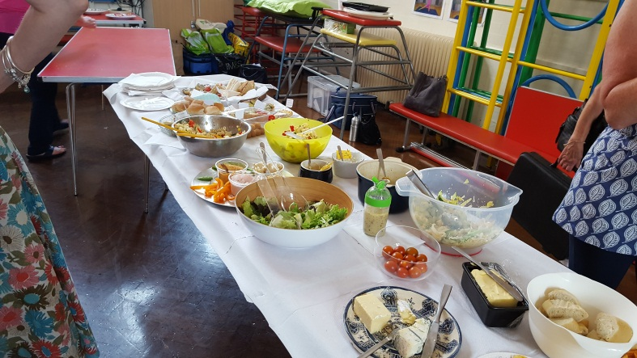

The WBSS lunch crew were amazing – setting out, re-arranging, clearing, organising drinks – so that the whole thing ran smoothly and also gave us all lots of time to sit in the shade or the sunshine and get to know one another. I was particularly impressed with the zeal with which Margaret attempted to conceal the afternoon tea cakes from view, so that they didn’t get eaten as lunchtime dessert. A very pragmatic approach based on our usual behaviour when cake appears! I will now reveal to you a comment I overheard in the kitchen – yes, you know who you are! ‘Well, she used to be a Wren, she’ll eat anything!’ Followed by a sudden realisation that the blogger was in the room! It’s no wonder people go quiet when I come in a room. I thought it was my awesome aura – but obviously you are all worried that whatever you say will end up in a blog. I can assure you that I am very discreet – except when it’s very funny! Or said by Simon!

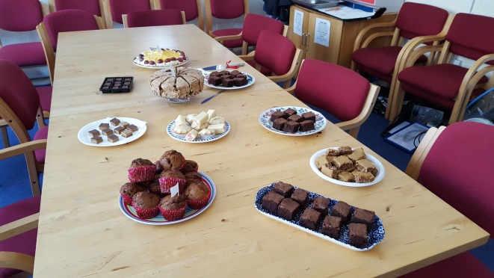

We spent the afternoon learning ‘Thank you for the music’ together. As always, Bjorn started near the end of the song which I am starting to appreciate is a clever piece of psychology (Simon does it too) so that when you then learn the beginning and reach the middle, Bjorn says ‘well, we know this bit’ and it feels great. We were encouraged to sing from our ‘third’ layer – which I am told by our Norwegian friends is Bjorn’s way of encouraging a singer to reach right down for a note. Either that or a tactful way of suggesting that some ladies have a larger tummy capacity than others! Whatever Bjorn says is full of good humour, enthusiasm, encouragement and I have never seen such a range of facial expressions. He literally shivers with delight when we sing something beautiful. You can hear the result of the afternoon via the FB clips and I’m sure that WBSS will be returning to this song in the future.

As a gesture of thanks, Simon presented Hedda with some sheet music to take home and also presented Bjorn with a pitch instrument, so he didn’t have to keep running to the piano, and a baton for this future choral success – although the way Bjorn was wielding it suggested he might have other uses for disobedient singers!
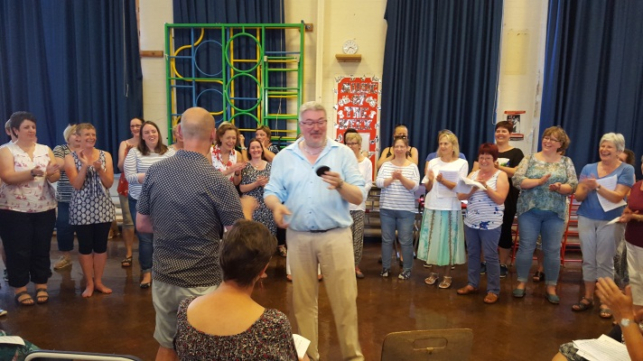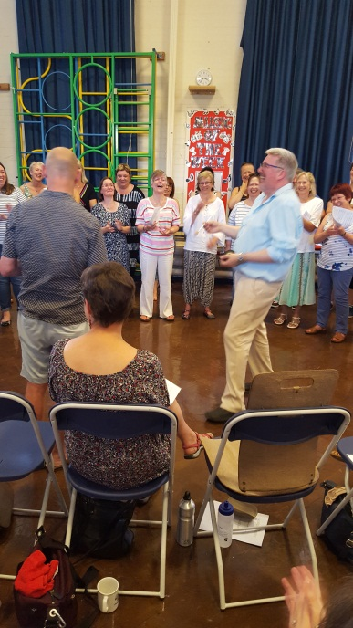

As I said at the start, ‘You’re my inspiration’ has been running through my head since Saturday and after a morning of rehearsal, the Bling singers joined Hedda to give us an amazing performance of it again at the end of the workshop. Listen to the clip and watch the video on FB – brilliant stuff!

A word to the WBSS guys. We missed you but we enjoyed our virtually all-female day and I know that is what you would have wanted us to do. Aah! Group hug!

So most of us said goodbye to Hedda on Saturday afternoon, but it sounds as if the day continued well at the Cross Keys. I hope the return journey was OK and that you don’t all go down with colds after returning from a sunny 28 degrees in Nottingham to a rainy 13 degrees in Trondheim. I wished Bjorn a Merry Christmas before I left, as I won’t see him until January, but I sincerely hope that our choirs can come together at some point in the future to repeat what was a wonderful weekend!

As a postscript, there are some great clips on You Tube of Hedda singing https://www.youtube.com/results?search_query=damekoret+hedda and of course on their Facebook page. I loved looking at the Facebook page and thinking –‘oh yes, I spoke to her’ – what a celebrity geek I am!

http://wp.me/p7DJ4Q-8P

