Happy Birthday to Us!
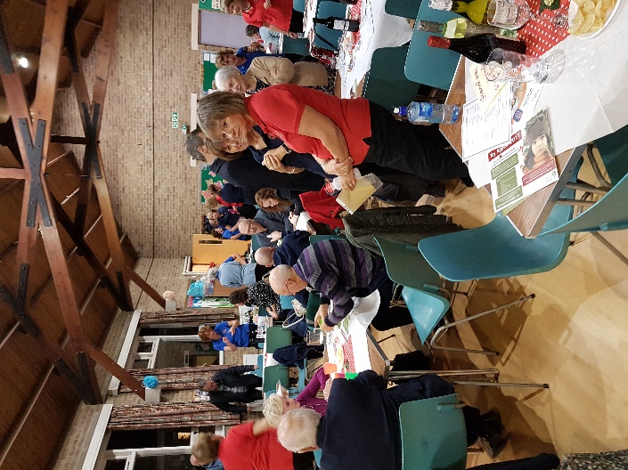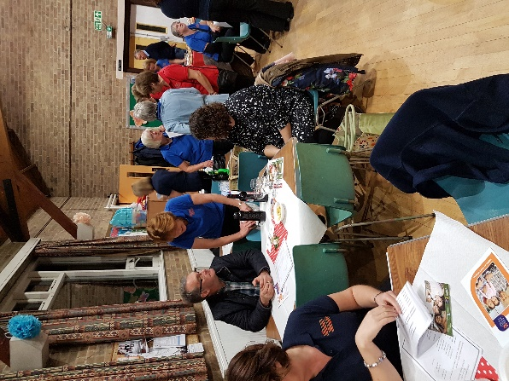

I like a good party. And I like a good birthday cake. We got both of those on Saturday night at St Paul’s. With a packed room of guests, most of whom had connections with the choir in some way, the atmosphere was warm, welcoming and positively buzzy. The sort of atmosphere that brings out the best in performers and I feel that we really rose to the occasion. I spoke to quite a few people at the interval and several said it was one of the best performances from the choir.
For me, the build-up started at the Tuesday rehearsal prior to the concert. Not only did we get a chance to work on the songs for the programme in choir formation, but there was a real confidence boost from not having to sing songs all the way through. Does that make any sense? When Simon waves his hands after a verse or an introduction, it feels like a validation of our efforts. My inner voice says ‘That one’s OK then’. And we, women’s parts (I won’t start that again!) were praised in very creative words. At one point, the altos were a ‘cushion’ for the sopranos and then I think the sopranos were described as a ‘bigger cushion’ – a futon, perhaps. And our director was in very descriptive mode; at one point, the altos were referred to as ‘stuffing the gaps’ and at another point as ‘hearty’. Although, I’m not sure that was a compliment so much as a hint that we were too loud! Then finally, we received a mega compliment – ‘magnificent’ – every alto heart was beating with a mixture of pride and a smidgeon of shock. But it certainly set us up for Saturday evening.
I’ve talked mainly so far about the women, but on Saturday night, the men really came into their own. They were truly magnificent and again, several people in the audience commented to me on the great male voices. I was standing in front of the tenors and it was brilliant. Sometimes, I was drawn into the tenor part – so I apologise to my alto colleagues for this - but the men really shone and their voices give such a richness to the songs – and not only the ones with ‘dum di dum’ in them! We are very fortunate.
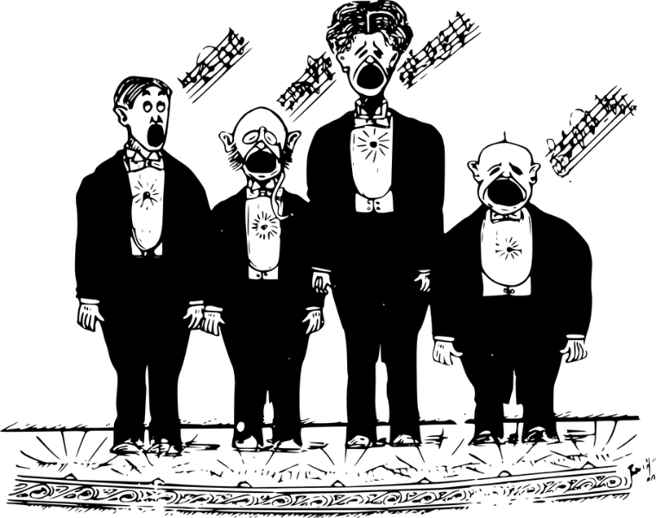

The programme was obviously indicative of our preferences, having been chosen by members, and it also showcased the wide range of music that we sing. Big ballads, musicals, gospel, emotional and of course, Norwegian. The songs which opened each part – ‘Kom’ and ‘Kebale’ – were great for us to warm up, but also added something different and perhaps unexpected for the audience.
What made this concert unique for me was the stories attached to the individual songs and it was very moving to listen to choir members describing the significance of the music for them and recalling occasions, often quite emotional, when a particular song played a part in their lives. How lovely that individuals wanted to stand up and speak to express the importance of music. Surely that is a strong indication of a commitment to and affection for the experience of our choir.
But no party is complete without food and cake. What a spread we provided for ourselves and our guests. Amazing organisation and logistics. As you can see from the photos, the table was groaning at the start and relatively sparse at the end. People were very polite and queued patiently and were very complimentary about the buffet. This was clearly aided by the various and abundant bottles on some tables (naming no names). I wonder whether this could also explain the increased audience participation in the second half. When I say that the table was sparse at the end, this did not include my large bowl of salad, which was pretty much ignored! But there were much more exciting salads to sample, so I am not bitter!
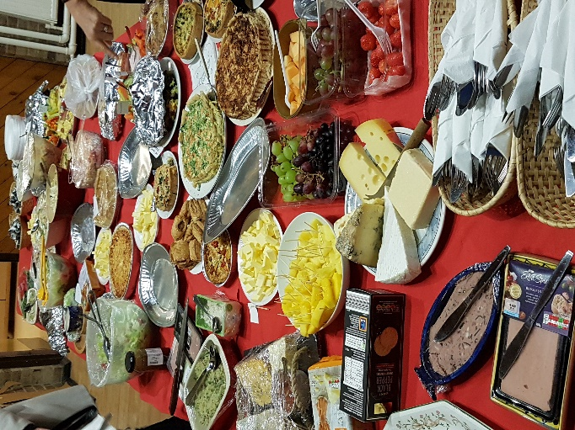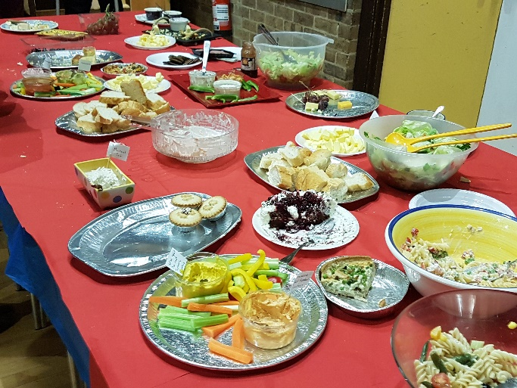

And that cake! Rex did us proud again, even though he admitted that Sandra had been the decorator par excellence. It was lovely, Rex – thank you so much; you give so much support to the choir. Most importantly, it tasted good. Because I am polite, I held back from the buffet to let the guests go first, but this gave me ample opportunity to get at the cake and I will admit that I had more than one piece! The photos and memorabilia on the table were really interesting – I had never seen the Social Singers Songbook before.

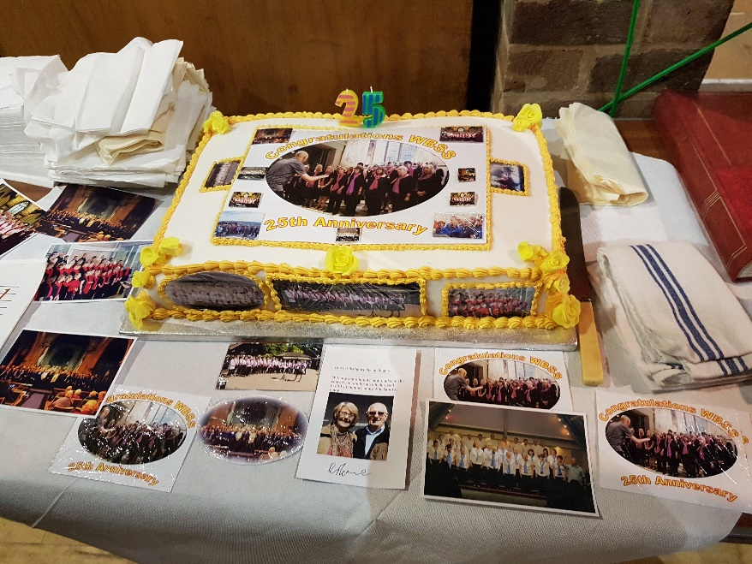
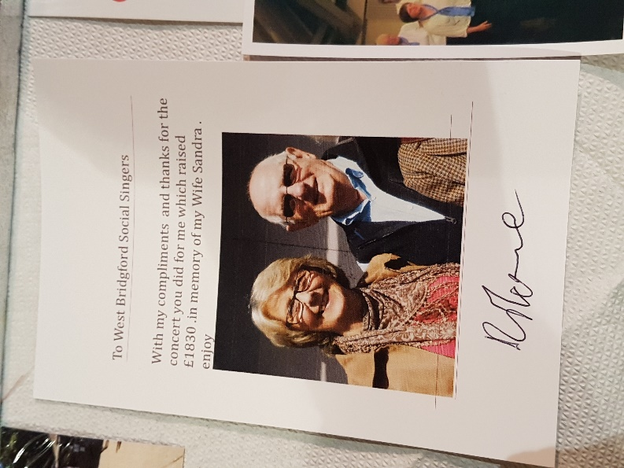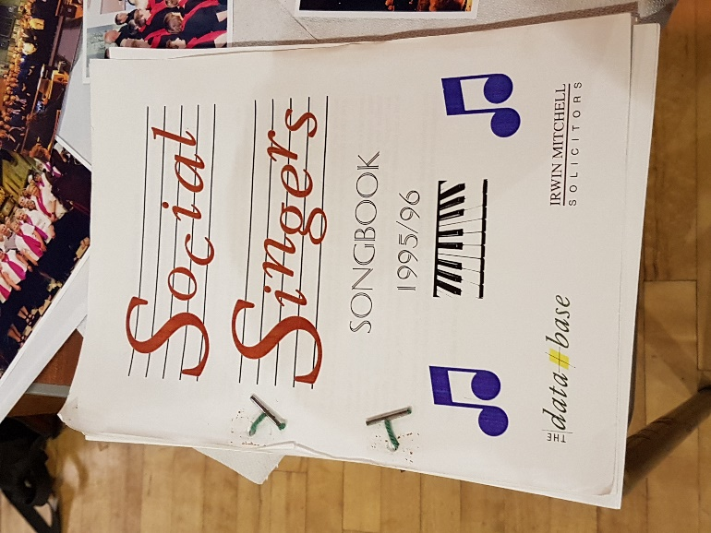

Our evening concluded with a showstopper – in true Bake Off tradition – Robin leading us in ‘Sit down you’re rocking the boat’. The arm and leg ‘ography’ was almost right, but where we lacked finesse, we made up for it in enthusiasm, good humour and the joy of singing. Obviously, the audience really did want an encore, even though they were too polite to ask for one, and Fiona was right in her reading of them. So a powerful and emotional rendering of ‘When you walk through a storm’ sent me, and I hope, everyone, home with a glow of celebration and achievement.
Happy Birthday to us!

https://wp.me/p7DJ4Q-ce

